The first spring Ray was on the Warden Service – I (Alf Burstrom) was working evening duty and was checking a bear trap in Whistler Campground. The trap was sprung and making a hell of a racket, banging and rocking back and forth. A terrible bawling could be heard.
“What to do?”
There were at least a hundred tourists standing around watching and more coming all the time. I couldn’t cut loose with a saw with all that attention I’d get. I had to get those cubs down. Of course we had no drugs in those days. I had a problem and needed help.
I radioed out to see if anyone was around. Ray and a couple other young fellows responded. I told Ray to bring some tarps and ropes with them. When they arrived, we moved the people back as much as possible. The plan was to shake the cubs out of the tree and catch them in a tarp.
We shook the first cub out, caught it and stuffed it in with it’s mother….and believe you me…that was no small task.
Next, cub number two. He just would not let go. We shook that tree until we were just played out, but there was no way the cub would let go. When it was obvious we were not going to get the cub down, Ray came up with the idea that he could climb the tree with spurs and a belt…far enough to get a snare on the cub and lower it down to us.
Now I knew Ray was an expert tree climber from working on the phone line crew. It might work. Of course I still wanted to give Ray a way out, so I asked him, “Are you sure you want to try this?”
“I think so.” was his answer. Away he went.
We rigged up a snare on a pole and Ray got his spurs and belt on, and up the tree he started. As he neared the cub, the tree was whipping back and forth and the cub climbed higher. Ray climbed higher. Ray was having a hard time hanging on so he got a wrap on the tree with his belt and got himself hooked in. By this time the tree was really whipping back and forth. Suddenly the cub lost his hold and down it came, wedging himself between Ray and the poplar tree
Now there was action…..!
The cub was squealing, biting and scratching. There was nothing between the family jewels and the cub but a pair of blue jeans. Ray grabbed that cub by the scruff of the neck…and he didn’t toss it down to us…Ray threw that cub at us!
We had a tell of a time catching it in the tarp.
Ray climbed down, when he reached the ground he remarked, “That was damn close!
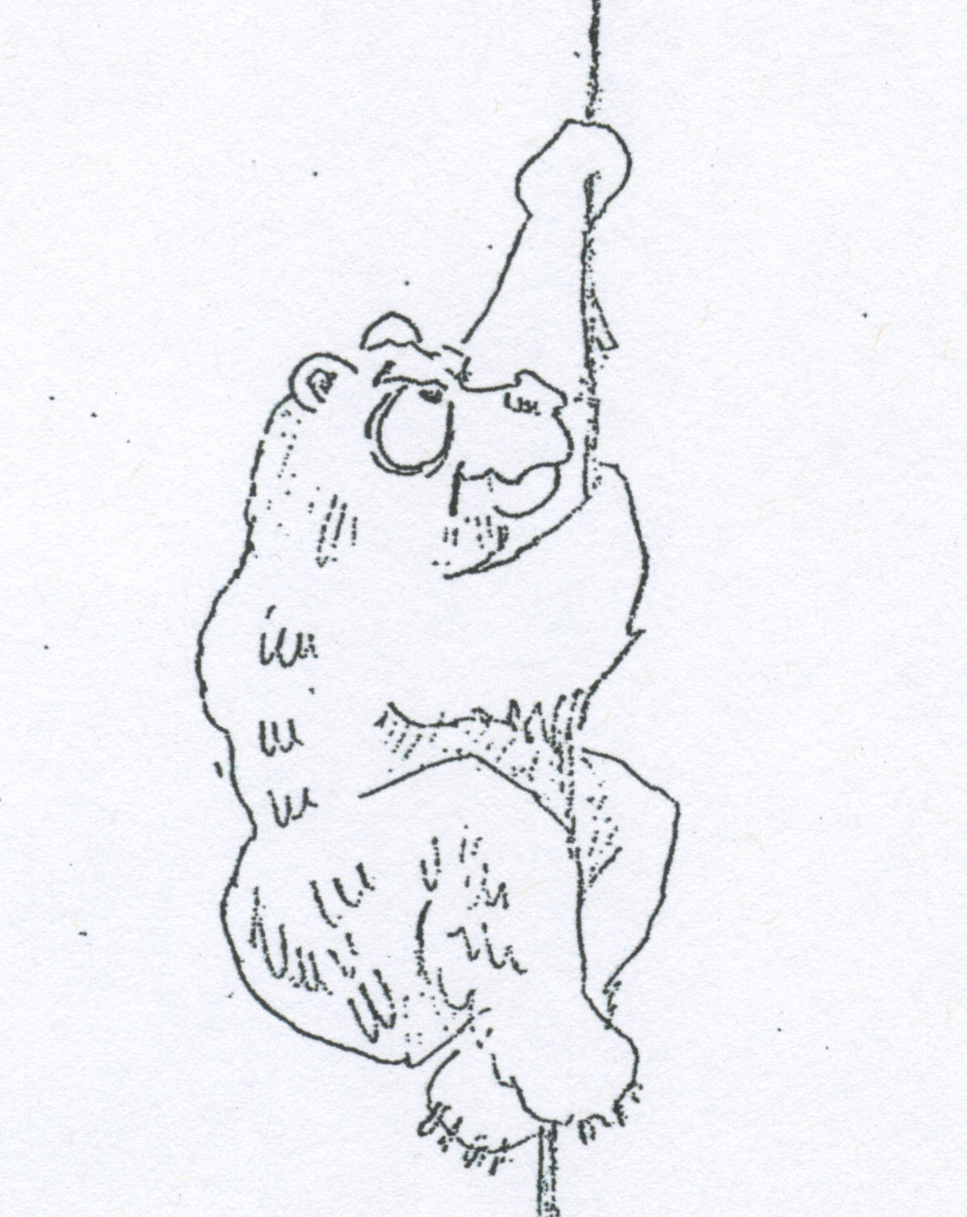
J. Strachan cartoon

