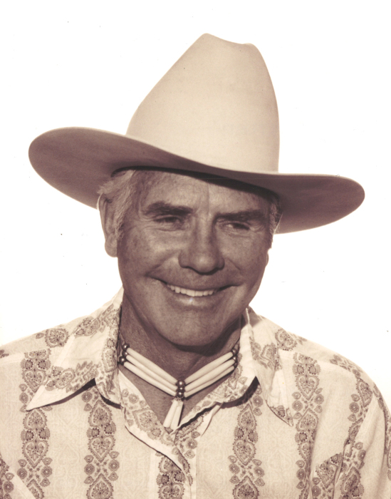

Donald Charles Brestler of Twin Butte, Alberta, beloved husband of the late Ingrid Brestler, passed away after his battle with cancer on September 25, 2019 at the age of 85 years. At his hospital bedside were his two daughters Joni and Cory, along with their husbands Maurice and Mike and other longtime friends and loved ones. Don was born in Calgary, Alberta where he received most of his schooling. He also spent part of his childhood life in Cardston before moving back to Calgary. Don met the love of his life, Ingrid, on a blind date set up by friends from Western Canada High School, and was smitten for the rest of his life, even after she had passed. He was a cowboy at heart and pursued the ranching life as much as he could, including time at the Knight Ranch, the Ya-Ha Tinda, and the McIntyre Ranch. Don also wrangled and packed horses around Waterton Lakes Park for Dave Simpson and Andy Russell. He enjoyed the beautiful vistas and fresh air in the southern Alberta Rocky Mountains. He even once rode a bronc in the Calgary Stampede as part of his cowboy dreams. Don was multitalented and was a self-taught artist, drawing and painting hundreds of pieces, some of which graced the interior and covers of the Canadian Cattlemen and the Western Sportsman magazines and several books. As part of his tenure in the Calgary Police Service in the 1960’s, Don sketched for the Patrol magazine. Many people received his artwork in the form of Christmas cards. He also enjoyed playing acoustic guitar and wrote over 360 of his own brand of songs and was the first musician to perform at the first Cowboy Poetry in Canada hosted in Pincher Creek. He was also a prolific writer and poet. Don always gave gratitude to God for his talents.

Anyone who knew Don well got to experience his abundant sense of humour. He brought smiles and laughter into the world and he will be missed by many. God bless Don on his journey home.
Family and friends were invited to pay their respects at the visitation at 7:00 P.M. on Friday October 11th at Eden’s Funeral Home, (966 Elm Street, Pincher Creek). A Graveside Service was be held at 11:00 A.M. on Saturday October 12 at Fairview Cemetery, Pincher Creek, where Don was laid to rest next to his beloved Ingrid. An Open House Memorial (Roast Beef Lunch) will follow at the Twin Butte Hall from 1:00 P.M. to 5:00 P.M.
Flowers are gratefully declined while donations may be made to the Salvation Army or The Mustard Seed.

