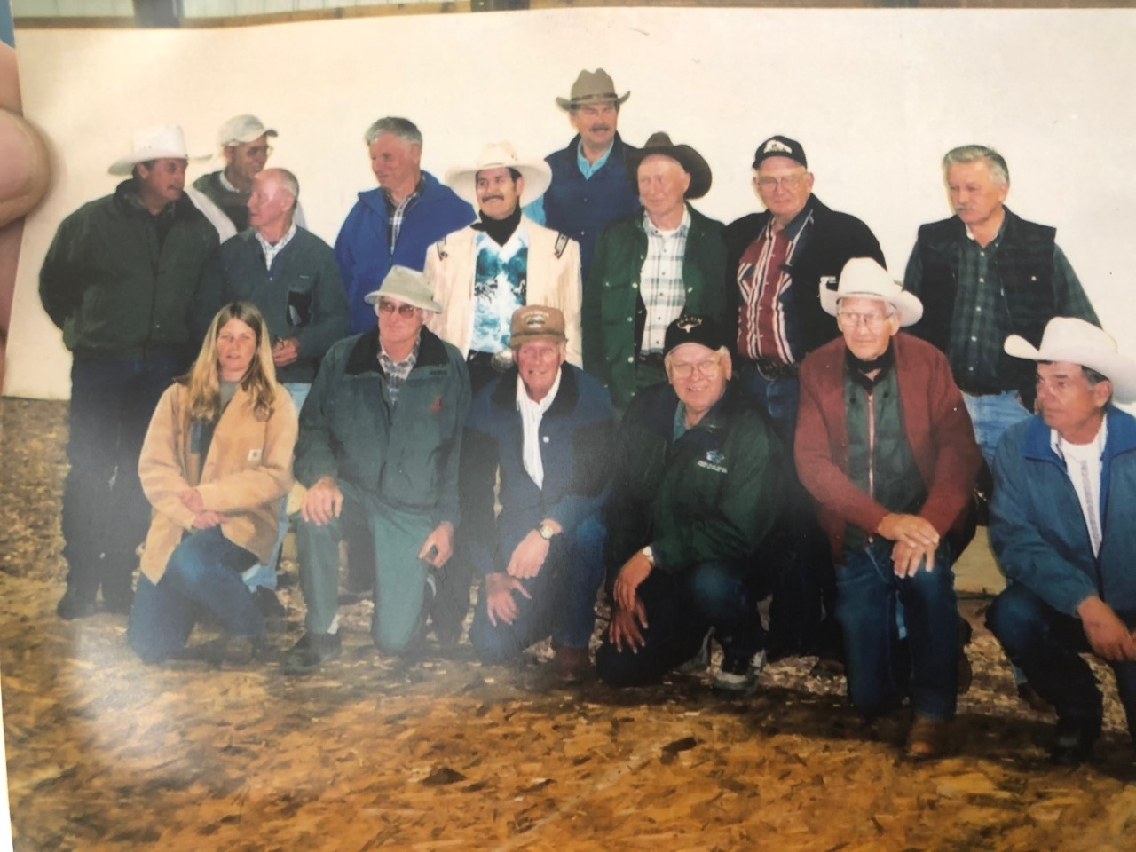JASPER WARDEN DAYS (circa 1995)
Back row: ?, Max Winkler, Gord Anderson
Middle Row: Darro Stinson, Toni Klettl, Bob Barker, Frank Coggins, Bill Walburger, Lawrence Baraniuk
Front: Trish Temblay, Abe Loewen, Bob Haney, Monrad Kjorlein, Mac Elder, Dennis Welsh

