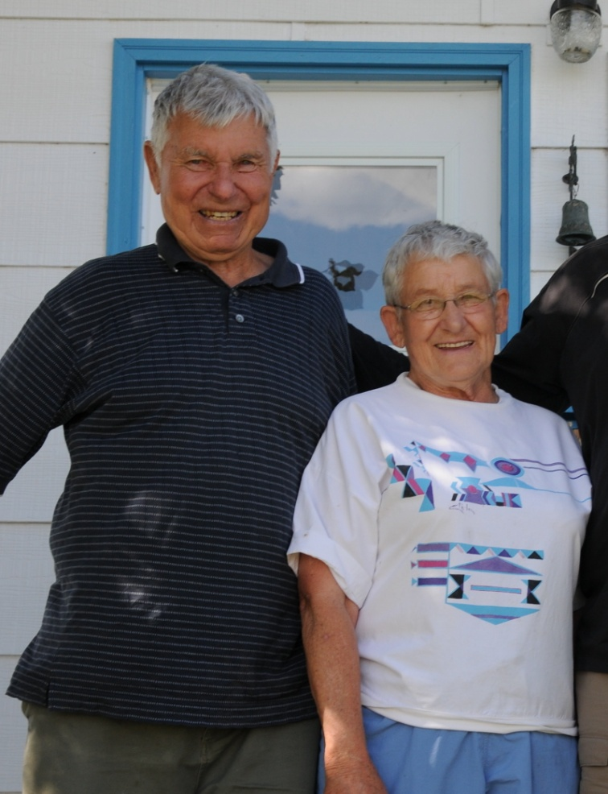
Julia Winkler Obituary
Julia Winkler of Pincher Creek passed away on January 14 2022 at the age of 92. Julia was born January 6, 1930 in Linden, Nova Scotia. She is survived by her son Terry, daughter in law Ursula, grandchildren Peter and Lisa and her sister Noreen. She is predeceased by her husband Max and her sister Muriel.
Julia worked as a teacher and social worker as she moved westward from the Maritimes. She met and married the love of her life Max and eventually moved to Jasper when Max became a park warden. They spent wonderful years in the backcountry and it was there that she began her 45 year career of woodcarving. She loved living in the four national parks in which Max was posted: Jasper, Kootenay, Forillon and Waterton.
A lover of the outdoors , she enjoyed a wide variety of activities in the world of nature including kayaking and hunting until she was 90. Her zest for life, love of learning, creativity and love of adventure always brought a smile to all our faces. Max and Julia’s various home in the parks and later retirement in Twin Butte were places where friends and family were welcomed. She was supported by loving friends of all ages who inspired her and who in turn she inspired. She believed that these loving relationships were among the greatest blessings of her long life.
We want to thank all you beautiful people far and wide who were so present in Julie’s life. Thank you for your friendship, for sharing adventures, laughter and love with her. Thank you for all the support and help you reached out to her especially during the last month of her life when she needed it so very much
We treasure you all
Terry Ursula, Peter and Lisa Winkler
A celebration of life will be held in the spring when the flowers return

