Park Warden Service
Alumni Society

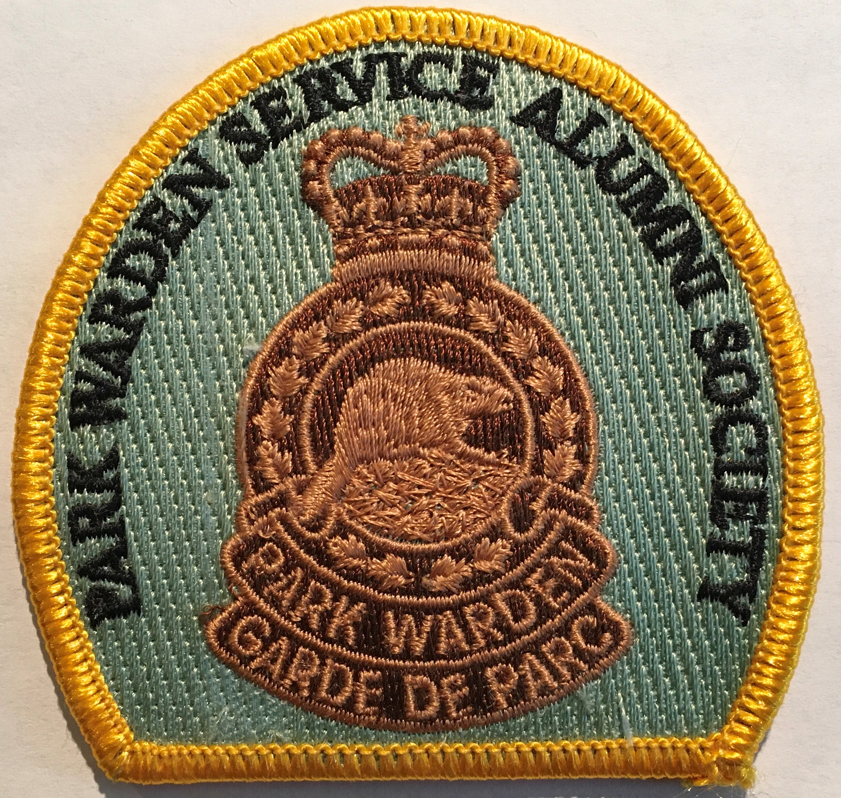

Strategic Plan
2024-2027

December 18, 2023
Incorporated in 2008 as a Not-for-Profit
2023 © PWSAS
Introduction:
The Park Warden Service was set up in Canada’s national parks as a multi-functional field unit in the early 1900’s. Its purpose was to protect the natural environment from visitor impacts and to protect visitors from the natural environment. A Park Warden’s role included a variety of duties including law enforcement, public safety, search and rescue, avalanche control, vegetation and fire management, fish and wildlife management and ecosystem monitoring.
In the mid 2000’s, Parks Canada Agency undertook a major restructuring of park-level operational services. The reorganization folded the multi-functional role of the Park Warden Service into the new Resource Conservation Field Unit. That strategic move eliminated the Park Warden Service as a stand-alone operational unit. The various duties, such as public safety, were taken on by specialists in each specialty role. Under the new organizational structure, those individuals serving as Park Wardens have the duty of conducting law enforcement. Under the new organizational structure, a Park Warden has become a “park cop.”
With the organizational change, Parks Canada effectively ended the 114-year long history of the Park Warden Service as an iconic operational unit. This led former Park Wardens to take steps to establish the Park Warden Service Alumni Society (PWSAS) to highlight and preserve the long and distinguished history of the Park Warden Service. PWSAS’s prime goal is to collect oral histories from former Park Wardens. With this information, PWSAS plans to confirm the Park Warden Service’s rightful place and reputation within Canada’s national park’s 138 year-long history. To aid in that task, PWSAS has developed a Strategic Plan to serve as a guide for its future planning and actions.
Strategic Plan:
The purpose of a strategic plan is to serve as the pathway for future alumni activities and events that benefit the membership and sets out a strategy and action plan to gather historical information about the past roles and stories of Park Wardens. A strategic plan establishes the focus that keep the Alumni on track with its intended mission and goals. The strategic plan sets out the planned activities for the next three years (2024 to 2027).
PWSAS forms a communication link with former and retired Park Wardens and Resource Conservation Specialists in the Parks Canada Agency. It was formed by retirees in western Canada, but its mission is to expand the membership to include Park Warden retirees in other regions of Canada. Initially, PWSAS’s goal was to create a conduit to maintain the close camaraderie that existed among Park Wardens prior to retiring. The mechanism to achieve that goal is set out in the mission, vision, common values, and goals described in this Strategic Plan.
The Strategic Plan not only provides guidance, but it also helps the organization to define how effective and successful we are at achieving our goals. One strategic priority we have set is to diversify our revenue sources to allow us to continue with the oral history project.
Mission:
The mission of PWSAS is to “Maintain the culture and traditions of the Park Warden Service by fostering good will and assistance to members through mentoring, volunteerism, historical commemoration, oral histories, advocacy and social activities.”
Vision: The vision for the next decade is for PWSAS to grow its membership Canada-wide and continue to represent the interests, history, and traditions of all Park Wardens that served in the former Park Warden Service. As the membership increases, more oral histories will be added to the current collection that, together, clearly describes the significant role that the Park Warden Service and individual Park Wardens played in preserving the ecological integrity of Canada’s national parks.
Values:
Our members’ common values are the core principles that define how we collaborate, how we approach our common goals, how we collaborate on an inter-personal level, and how we promote retirees’ well-being. Our values align with our mission and vision and include teamwork, service, loyalty, honesty, communication, and respect. These values help to build the foundation for our purpose-for-being and are highlighted in this strategic plan.

Goals:
Over the next few years we plan to achieve the following goals.
Goal 1: complete twenty additional oral history interviews with retirees to add to our existing collection of 114. The 114 interviews may be found on the PWSAS website (parkwardenalumni.com) and accessible in the Archives at the Whyte Museum of the Canadian Rockies in Banff, Alberta.
Goal 2: To continue to expand the PWSAS membership to become inclusive of all Parks Canada Regions. We intend to promote the Park Warden oral history project in other Parks Canada regions based on the interview template established in the Western Region. We intend to archive these oral histories in a safe location (Whyte Museum) for future reference. All oral histories will also be available on the PWSAS website.
Goal 3: To increase revenue to support the oral history project by holding the sale or auction of items donated to PWSAS. Donated items for sale or from a silent auction have returned considerable revenue to the PWSAS.
Goal 4: To continue to hold an annual mini reunion for members to re-engage with former colleagues. The next reunion is planned for early May 2024 in Salmon Arm, B.C.
Resources:
PWSAS is a volunteer-run not-for-profit organization. No one is a paid staff person. We do contract with experienced historical research interviewers to conduct the face-to-face interviews, each on a contractual basis. The source of revenue to sustain the organization comes from membership fees, members donations, silent auction sales and government grants. An organizational chart of PWSAS’s structure is Attachment 1. Audited financial statements are available upon request and presented at the AGM.

Action Plan/Tactics:
PWSAS’s current priority is the continuation of the oral history project.
Action: Continue to find funding to support the oral history project. Without funding, the tactic is to rely solely on membership fees and donations to complete five face-to-face interviews. With government funding support we can usually complete five additional interviews, for ten each year. We have more people to interview.
Action: Pursue funding from government sources that support historical research. Funding will be pursued with the federal government’s Documentary Heritage Communities Program. Failing that, other sources of funding will be explored.
Action: PWSAS will continue to hold silent auctions and sales with items donated from the membership. One item at a time over the year will be auctioned off.
Action: Continue to encourage membership of former, retired, and supportive individuals from across Canada. The goal is to maintain or increase membership to ensure a healthy organization for years to come.
Action: Plan an annual mini reunion at various times of year and at locations across Canada.

Approval:
The strategic plan for the Park Warden Service Alumni Society is approved by a motion at the Board of Directors December 18, 2023, meeting.
Position Signature Date
President David Reynolds
Vice President Cliff White
Secretary-Treasurer Marie Nylund
Directors
Kathy Calvert
Perry Davis
Perry Jacobson
Eric Langshaw
Don Mickle
Jim Murphy
Dale Portman
Colleen Reynolds
Alan Westhaver

Attachment 1

Park Warden Service Alumni Society
Organizational Structure
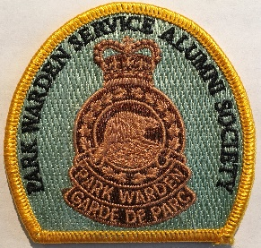
Society Membership
Vice-President
Dr. Cliff White
President
Dr. David Reynolds
2023-2024 Board of Directors
Dale Portman, Kathy Calvert, Jim Murphy, Don Mickle, Perry Davis, Colleen Reynolds, Perry Jacobson, Alan Westhaver, Eric Langshaw
Secretary-Treasurer
Ms Marie Nylund

