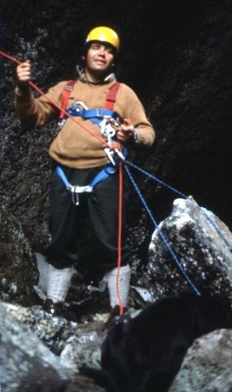
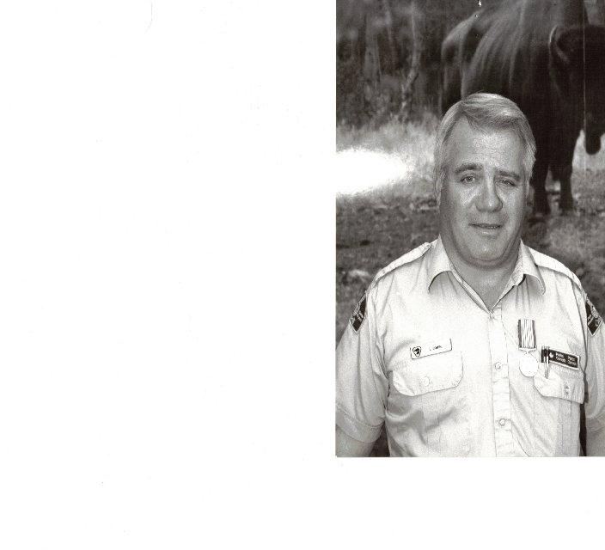
Lou’s Farewell Gathering
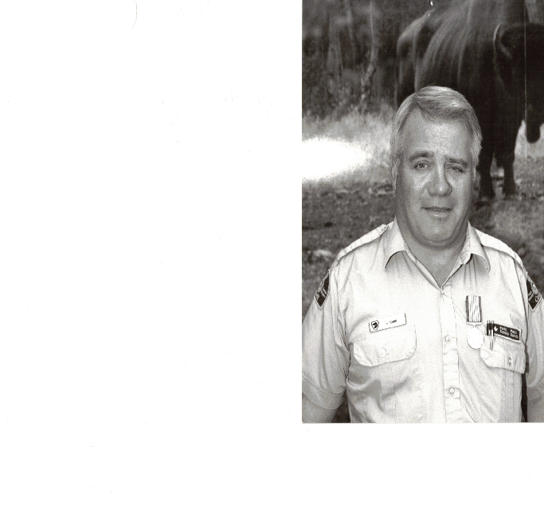
Louis Comin
June 25, 1947 - Mar 15, 2024
A Celebration of life will be held for Lou on June 22, 2024
at their home located 4461-48^{th street}, Canyon, BC 250-428-2034
As per Lous request, open house with BBQ and alcohol to flow freely all day
Sunday Brunch
All to be provided, just bring yourself and stories to share
Any pictures or tall tales of Lou can be forwarded to Wade or Tom Elliot
For those of you who may be here early, supper and
memorial poker game at Wade’s home
3480 Phillips Road, Lister BC on June 21, 2022
Wadecomin@gmail.com 867-333-9894©
RSVP Wade or Tom
- Friends and family are welcome to camp on the property or there are campsites up the road available at Canyon Park at $20
- Many local hotels and Air bnb’s in area – google search

