A Tribute to Lou:

One thing about being our age, is that most of the tales I’m about to share were well before cell phones. Probably a good thing for the most part, but had they been around, it certainly would have livened up Lou’s slide show.

My introduction to Lou was by a mobile radio phone interview in 1979 for a GT-1 seasonal position at Nahanni. It wasn’t a typical GT-1 interview of that era, but certainly a practical one. Lou asked if I could canoe, operate a motorboat, manage on my own in the backcountry, and the question I remember most, could I swim? He never qualified this with “in water just above freezing temperature.” I guess he was just anxious to have someone fill the position.

I spent 3 summers and one winter at Nahanni and got to know Lou, Cheryl, and the kids quite well. I learned a lot from Lou during that time as he became my mentor.

Nahanni was isolated with only boat or aircraft access. You quickly learned to be self sufficient servicing everything from the diesel power plant, outboard motors, and jet boats to mobile home furnaces. I watched in amazement one time as Lou neutered his cat using ketamine from the bear kit. He and I were partners in a dog team and Lou demonstrated how to break up dog fights without being bitten too badly; and my collection of cuss words grew significantly. Not exactly your typical seasonal warden training.

Lou and Cheryl looked after the seasonal staff very well. Cheryl’s chocolate chip cookies were my favourite. They sent their black lab Kelly to keep me company on my 10-day shifts at Rabbitkettle Lake. At the start of my second season, Joe Buker and I brought in by boat, a large supply of groceries, equipment, and assorted other things needed to get us through the summer. Included was a keg of beer that Lou bought for a welcome back party. On arrival, the keg was quickly tapped. We spent the evening playing Inuit games taught to us by the Nahanni Butte school teacher at the time, Wendall Whyte. Wendall recalled game losers had to walk the post railing fence around the office – a challenge after a few wobbly pops. By the time we got into a game of hearts we were all well lubricated. Our beer pitcher had to be refilled from the root cellar of the office cabin next door. Card game losers had to get the refills. Wendall, Joe and I all had every combination of winning card hands hidden about us, so we never lost. Lou had to fetch round after round of beer, never figuring out what we were up to, despite him being the poker player he was. We laughed and laughed, but Lou was a good sport despite loosing.

If you knew Lou, you frequently saw how strong and tough he was. One winter we came out to winter rendezvous in Whitehorse. Lou placed first or second in the flour packing competition carrying in excess of 900 lbs. On our return trip to Nahanni, we overnighted in Fort Nelson. Our hotel bar had a mechanical bull and we watched as a series of young oil riggers tried to ride it, barely lasting the first round if at all. Lou decided to give it a go. He lasted round after round to loud cheers before finally getting bucked off. The next morning Lou was black, blue, purple, and green from his crotch to his knees. Didn’t seem like such a good idea then.

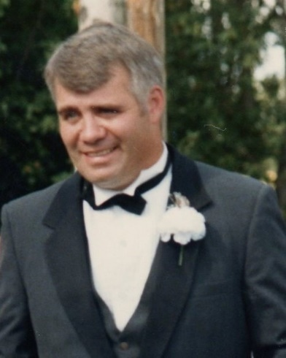
At our wedding we got into some arm wrestling go rounds. Lou lasted until the end before meeting his match against Penny’s younger and bigger farming brother. Despite all his rough and gruff exterior, we managed to get Lou to wear a tuxedo at our wedding. Not something I think any of us would have imagined, but he wore it well, eh Cheryl.

We all have our bear stories and one of the best I ever heard, involved Lou and Chris Hammond another seasonal. At the Nahanni Sunblood warden cabin, Lou and Chris had gone to bed. At some point that night, a grizzly poked his head through the window glass above Chris. Mayhem pursued with Lou and Chris hopping about bare foot in their skivvies amongst the broken glass; yelling and swearing at each to get the firearm only to discover it wasn’t loaded. All ended well, with Chris eloquently writing up the story in the cabin log with lots of bold capital letters, expletives and explanation marks. Reading it brought tears of laughter to my eyes. Where is the camera when you need it.

Lou was always up for an adventure and learning something new. Nahanni is known for its first canyon caves and Lou always wanted to get into the largest one, Grotte Mickey. The challenge being it was inaccessible, near the top of the canyon on a sheer cliff face. Putting our climbing skills into practise following a Willie Pfisterer school. Joe led our climb up the canyon wall below the cave entrance. Unfortunately, we underestimated the time it would take to reach the cave. We went to plan B, gave up on the explore, and got to the top of the canyon at dusk. Not expecting an overnight, we had no food, tent, or sleeping bags, just the clothes on our back and the remains of our lunch. We stood around congratulating ourselves on our climb and swatting mosquitoes. As it got darker, I found a soft mossy area to lay down and try to get some sleep. Joe joined me a short time later a foot or so away. Not long after that we were joined by Lou squeezing into the middle. Yes, a bit uncomfortable. It wouldn’t be the warden way to call it spooning, but as directed by Lou, we moved closer together for warmth, and who’s going to argue with him. Good thing no cell phones, eh?

In any case the next morning we set up a series of repels down to the boat. Determined to finish the explore, we returned to the site by helicopter, and we repelled down to cave entrance from above. From there it was a crawl through a small 50-metre-long tunnel, through 6 inches of frigid water over ice, before things opened up to a series of huge open galleries.

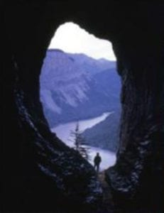
With miners’ lamps and following by a previous explorer’s map, we went up, down, around and about until coming to a narrow hole we had to get through on way back to the cave entrance. Two of us went first with no problem, followed by Lou who got stuck. Me and the helicopter pilot pulled Lou’s arms while Ray Breneman and a national geographic writer pushed his butt from below. With considerable effort, grunts, groans and laugher, we finally managed to get Lou through the hole. Once again for Lou’s sake, it was a good thing we didn’t have cell phones.

You can’t tell stories about Lou without a hockey story or two. At the Invermere hockey tourney one year Lou bunked with Jim Morgan. We were woken in the middle of the night by Jim pounding our door and yelling “it’s Lou, I need help. He’s going to die” over and over. We got up, went next door to find a well lubricated Lou on his back on the bed gagging. An inebriated Jim was sitting on his bed, head in his hands facing Lou, repeatedly saying, “Lou’s dying, who’s going to give him artificial respirations, I’m not. He’s going to die”. I don’t think it was as bad as Jim thought, but to his credit he had wherewithal to get help. We got Lou in recovery position, and again, all ended well.

A second story involves the Calgary Flames the year they won the Stanley Cup. I had met Jim Peplinski, Doug Riseborough and Bob Murdoch while they were hiking Pangnirtunq Pass in Auyuituq. At a CPW meeting in Winnipeg the following winter, the Flames were playing the Jets. We got tickets, got there early, and went down to players’ bench. I caught Peplinski’s eye, and he skated over and told us to meet him after the game in the player’s exit tunnel. There, he invited us to ride the team bus to a pub for victory drinks. Lou’s eyes lit up when Doug Riseborough joined our table and let Lou try on his Stanley cup ring. We were sitting with likes of Tim Hunter, Lanny MacDonald, Al McInnes, Joe Mullen, Theo Fluery, Doug Gilmore, Gary Suter, Hakon Loob, etc. How do you beat that, unless you’re an Oiler’s fan, I guess.

It wasn’t all just fun and adventure with Lou. His contribution to the ecological integrity of parks is well documented. Maybe George will speak to details of Lou’s time at Wood Buffalo, but something I noticed from my perspective from having worked there myself, was that Lou had built a strong warden team. Wood Buff went from a park where wardens quickly passed through after two or three years, to one where people spent several years there. Lou played an important role in getting the right people to join him and giving them the responsibility and freedom to do their jobs. During Lou’s time at Wood Buff, along with his team of dedicated wardens, significant changes in the fire program occurred, logging in the timber berth was shut down, and the bison cull and Garden River Road were stopped. Something to be very proud of.

Lou had a philosophy for work being, “you can do things right” ie by the book or according to management direction etc, or “you can do the right thing”. Lou was an advocate of doing the right thing and I’m sure that philosophy played a role in the Wood Buffalo accomplishments, and through out Lou’s career.

I have been fortunate and blessed to have Lou, Cheryl, and family as friends for some 45 years or so. I miss you Lou and will remember you fondly. Thankyou for your friendship, mentorship, and memories and your foresight in preplanning this gathering with Crown Royal. And lastly, a big thankyou to Cheryl, Wade and Nicole for hosting this gathering and all your work in putting it together. And closing, not to get too teary, but to stay in line with Lou’s last wishes, a toast to Lou. Here’s to Lou!
As written and read by Tom Elliot, a seasonal for Lou 1979 to 1981.

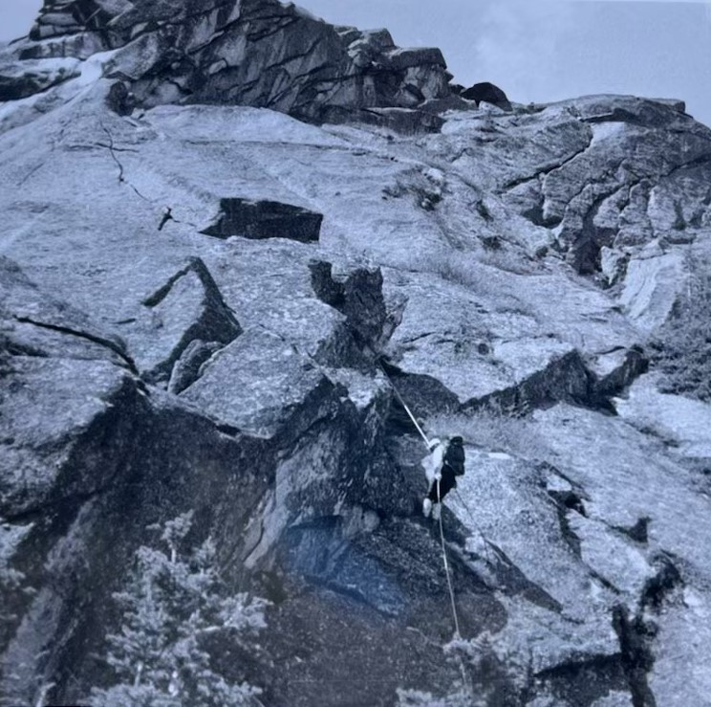

1Lou with Kelly in his backpack

Wendall also spent a summer as a Rabbitkettle park warden.

